1. <http://localhost/enrollment/admin/add_payment.php?stud_number=000000%20&stud_name=DUMMY,%20DUMMY%20DUMMY>

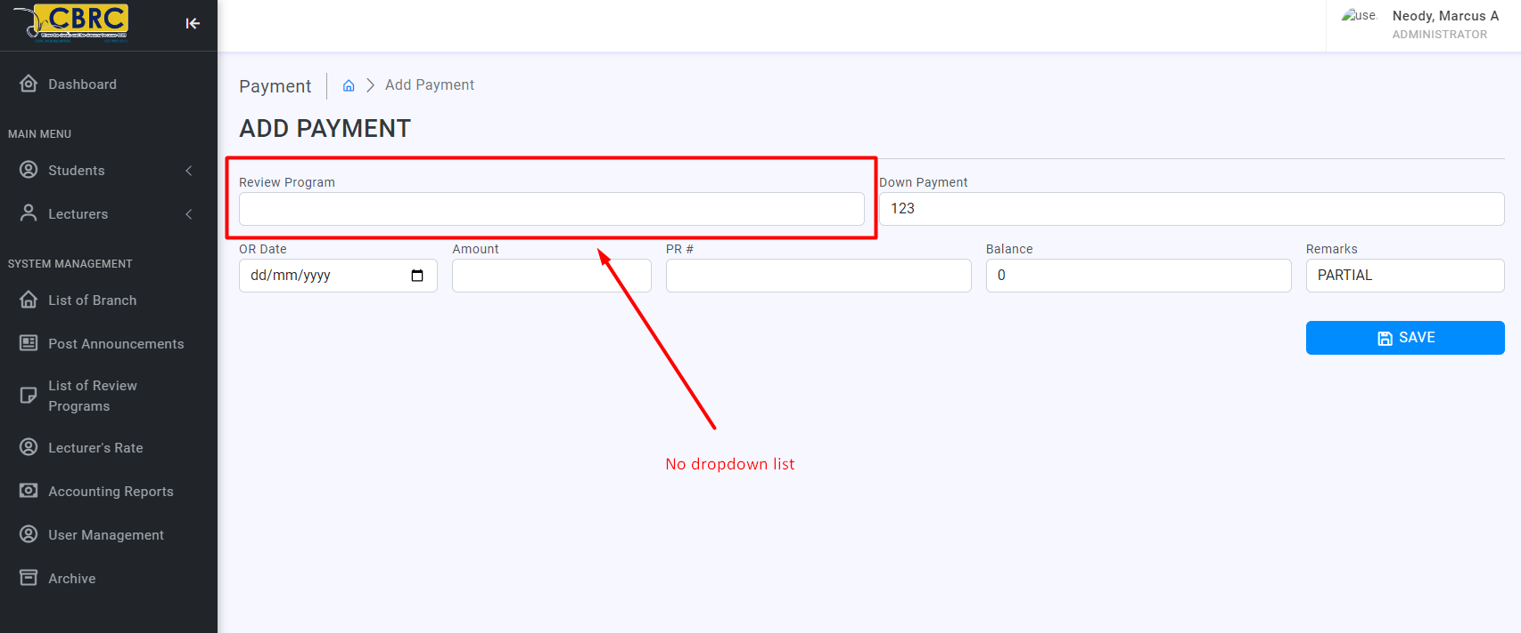

1. <http://localhost/enrollment/admin/success_page.php> **(Neil)**

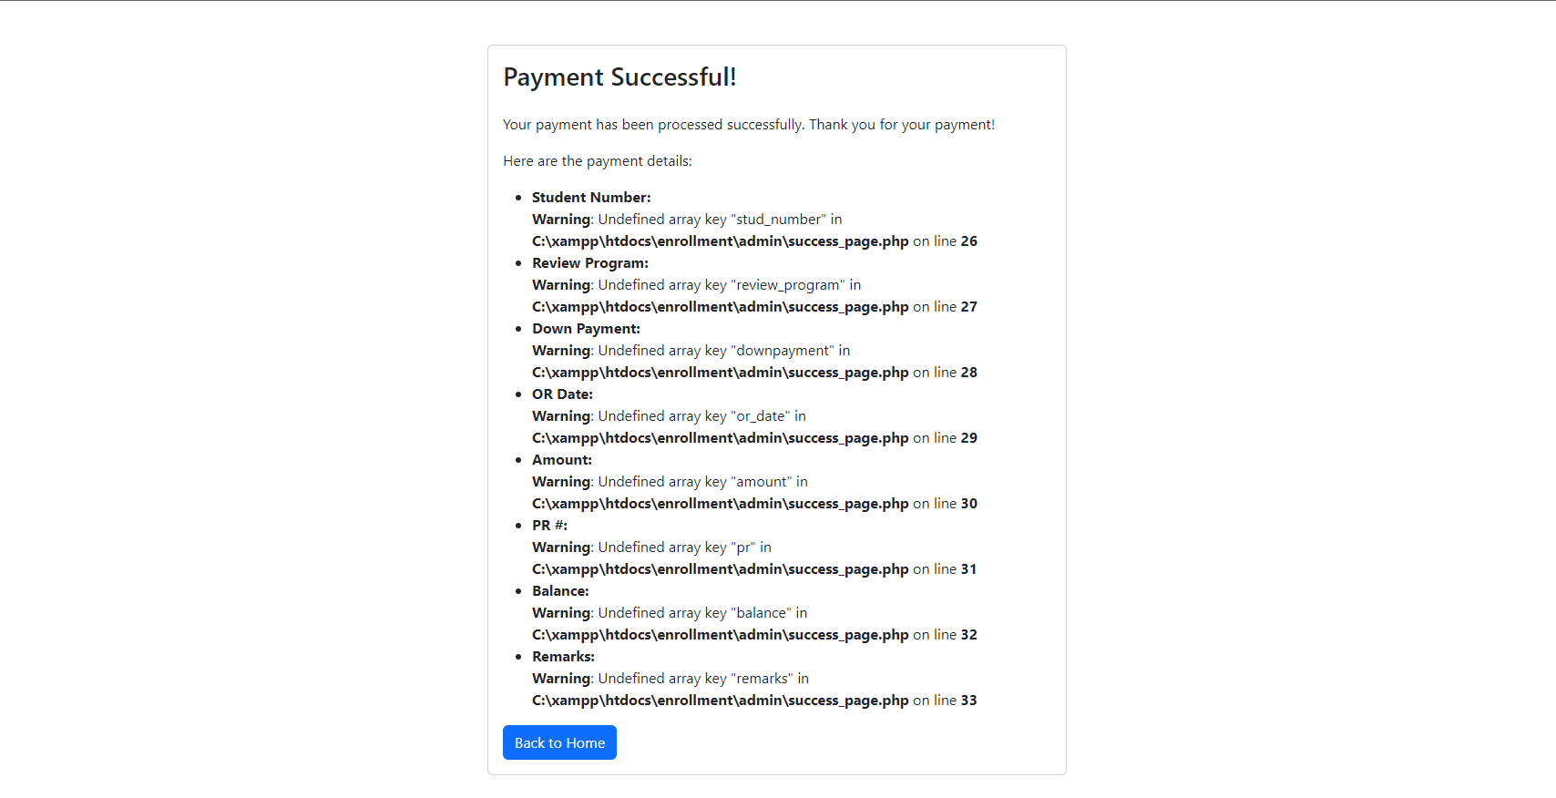

1. <http://localhost/enrollment/admin/student_list.php>

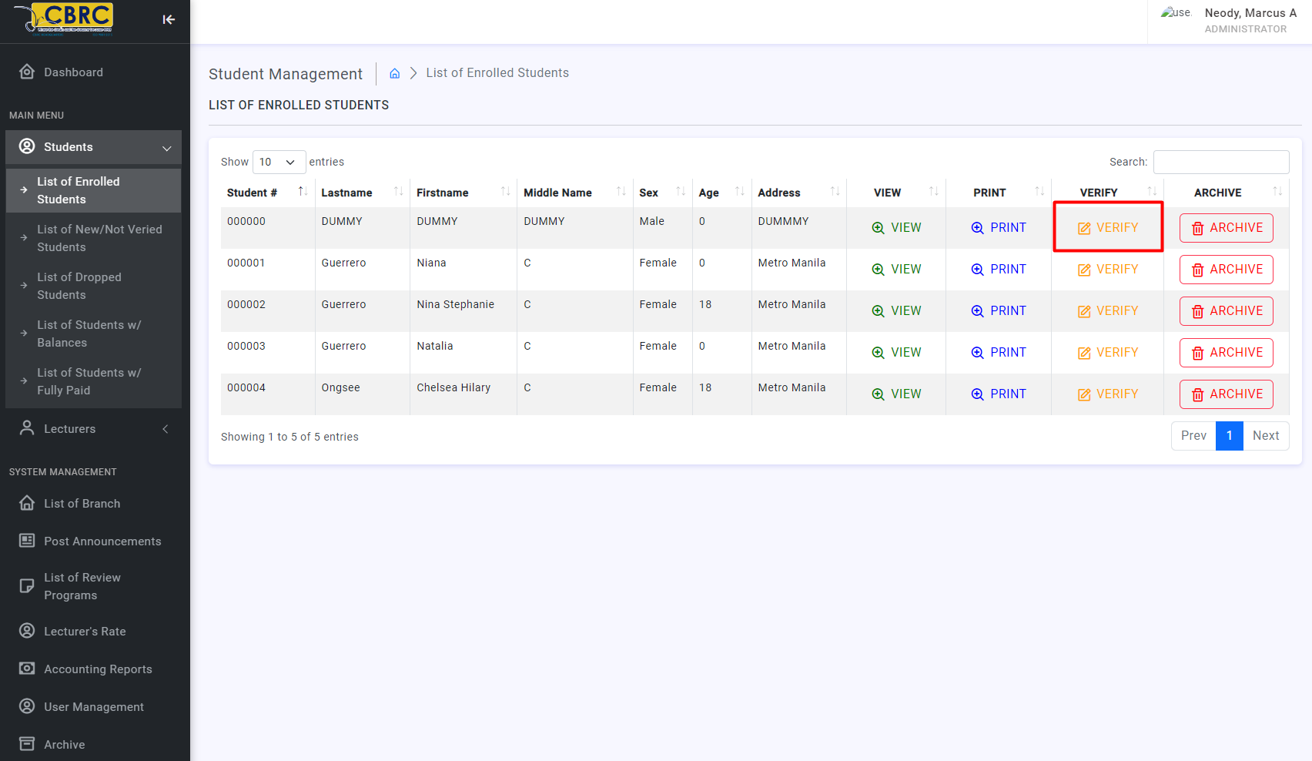

After click ng “Verify” button

**Warning**: Undefined array key "id" in **C:\xampp\htdocs\enrollment\admin\edit_student.php** on line **3**

**Fatal error**: Uncaught mysqli_sql_exception: Unknown column 'student_numer' in 'where clause' in C:\xampp\htdocs\enrollment\admin\edit_student.php:5 Stack trace: #0 C:\xampp\htdocs\enrollment\admin\edit_student.php(5): mysqli_query(Object(mysqli), 'UPDATE es_stude...') #1 {main} thrown in **C:\xampp\htdocs\enrollment\admin\edit_student.php** on line **5**

1. <http://localhost/enrollment/admin/process_add_lecturer.php>  **(Aug2 ganun pa din)**

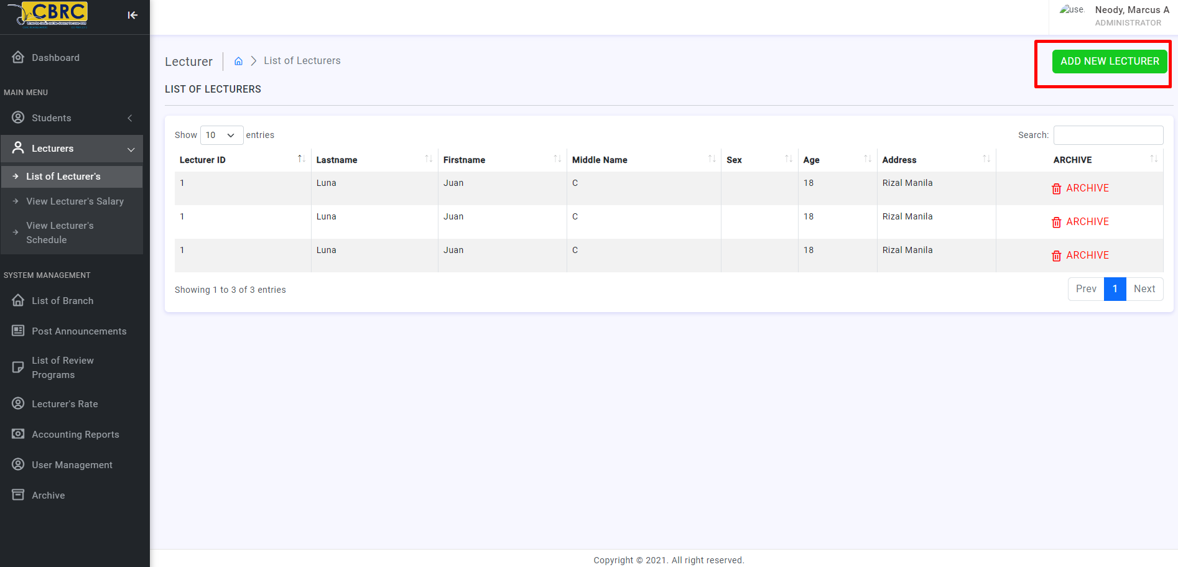

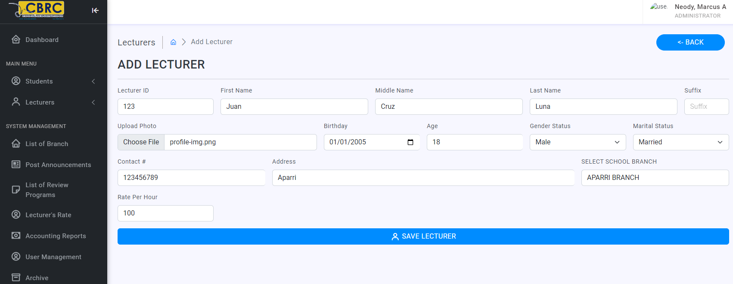

1. Not auto generate nung Lecturer ID
2. Pag click ng **“Save Lecturer”** Button

**Warning**: Undefined array key "school" in **C:\xampp\htdocs\enrollment\admin\process_add_lecturer.php** on line **25**

**Warning**: Undefined array key "year_graduated" in **C:\xampp\htdocs\enrollment\admin\process_add_lecturer.php** on line **26**

**Warning**: Undefined array key "educ_attainment" in **C:\xampp\htdocs\enrollment\admin\process_add_lecturer.php** on line **27**

**Fatal error**: Uncaught mysqli_sql_exception: You have an error in your SQL syntax; check the manual that corresponds to your MariaDB server version for the right syntax to use near '..., column19) VALUES ('1001', 'joey', 'V', 'Rigon', '', ..., 'MABALACAT BRAN...' at line 1 in C:\xampp\htdocs\enrollment\admin\process_add_lecturer.php:33 Stack trace: #0 C:\xampp\htdocs\enrollment\admin\process_add_lecturer.php(33): mysqli_query(Object(mysqli), 'INSERT INTO `es...') #1 {main} thrown in **C:\xampp\htdocs\enrollment\admin\process_add_lecturer.php** on line **33**

1. <http://localhost/enrollment/admin/delete_lecturer.php?lec_id=1> **(Aug2 ganun pa din same with “List of Lecturers” and “View Lecturer’s Schedule”**

**“Archive” button**

Nag di direct lang sa “Archive” Tab pero wla dung data na ini archive

**Here’s the list of pages that has “Archive” button please apply the same function that is working on**

**here: http://localhost/enrollment/admin/student_list.php**

http://localhost/enrollment/admin/user_management.php

http://localhost/enrollment/admin/lecturers_salary.php?lec_id=1%20&%20lec_name=test,%20test%20test

http://localhost/enrollment/branch/process_enroll_student.php

http://localhost/enrollment/admin/unverified_student_list.php

http://localhost/enrollment/admin/lecturers_list.php

http://localhost/enrollment/admin/lecturers_sched.php

http://localhost/enrollment/admin/announcement.php

http://localhost/enrollment/admin/review_programs.php

http://localhost/enrollment/admin/user_management.php

http://localhost/enrollment/branch/view_announcement.php

<http://localhost/enrollment/admin/branch.php>

1. <http://localhost/enrollment/branch/add_student.php>  **(Assigned to Neil - Aug2 ganun pa din)**

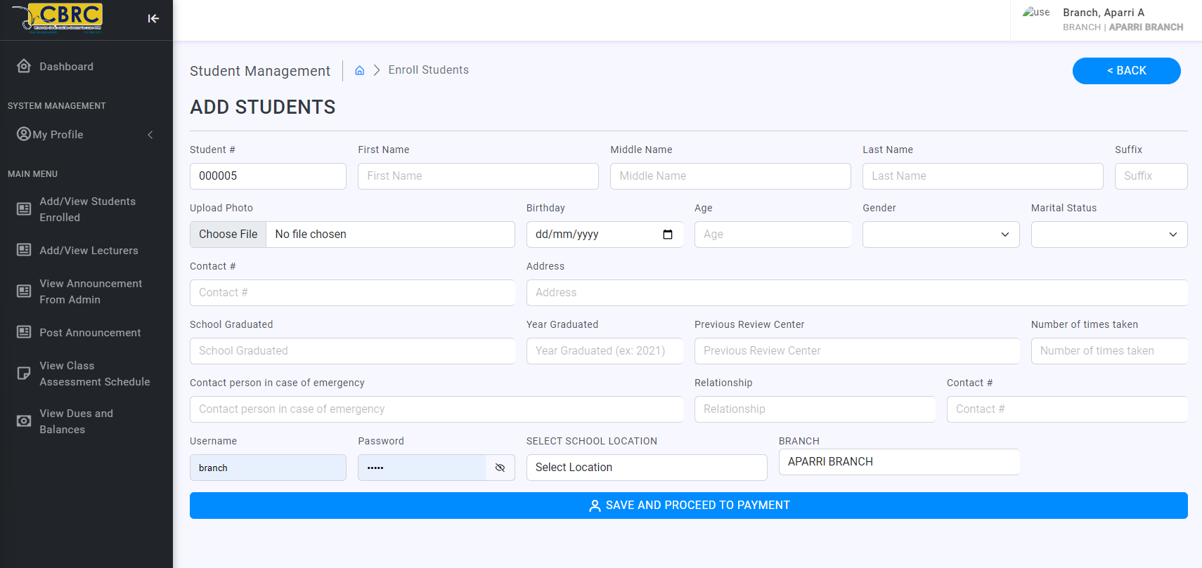Dapat po yung branch admin yung nakakapag enroll. Hindi po ito gumagana dahil may condition siya Nawala

**Fatal error**: Uncaught mysqli_sql_exception: Column count doesn't match value count at row 1 in C:\xampp\htdocs\enrollment\branch\process_enroll_student.php:42 Stack trace: #0 C:\xampp\htdocs\enrollment\branch\process_enroll_student.php(42): mysqli_query(Object(mysqli), 'INSERT INTO `es...') #1 {main} thrown in **C:\xampp\htdocs\enrollment\branch\process_enroll_student.php** on line **42**

1. <http://localhost/enrollment/student/dashboard.php>

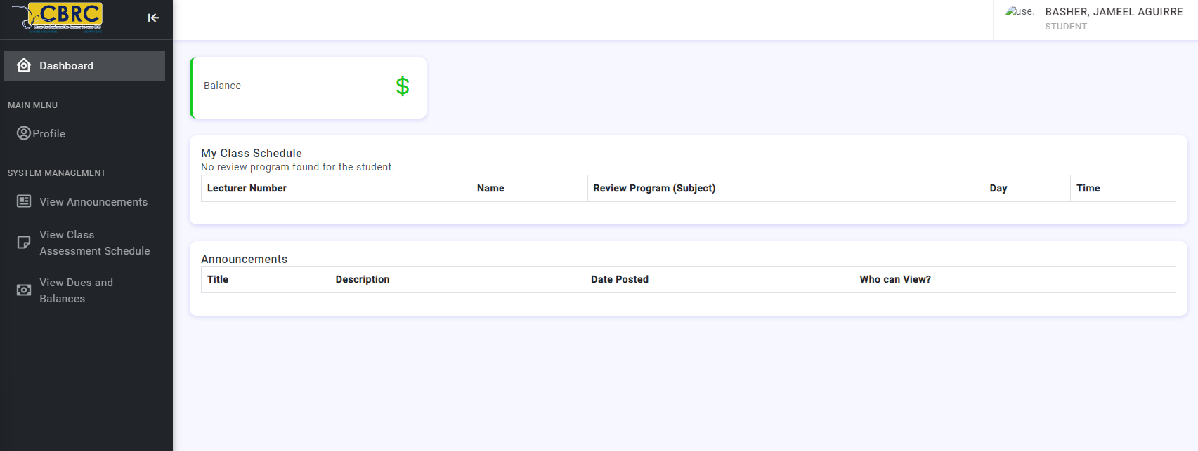

dapat makikita yung info ng student at kung anong program yung inenroll niya pati announcement and yung balance niya

1. <http://localhost/enrollment/admin/view_stud_record.php?stud_number=000001%20&%20stud_name=Guerrero,%20Niana%20C> **(DONE by YUKI)**

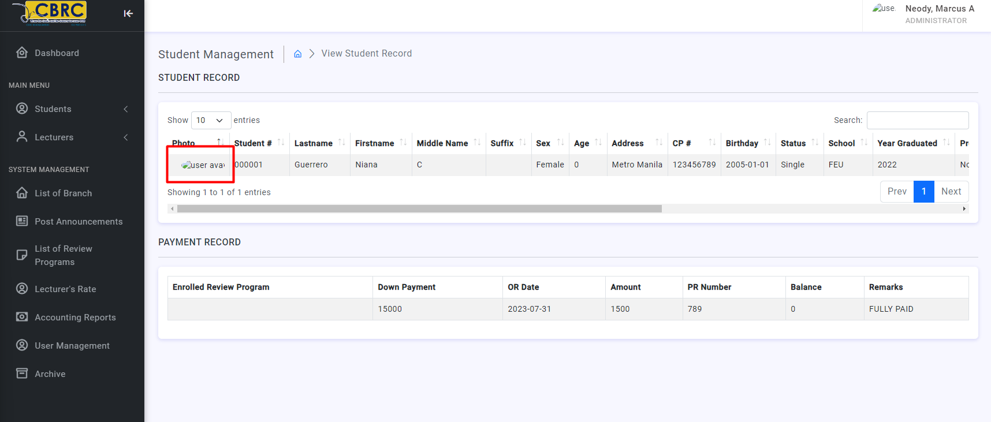

The photo should be clickable, pag click lalaki yung image like mag zoom-in

1. <http://localhost/enrollment/admin/announcement.php>

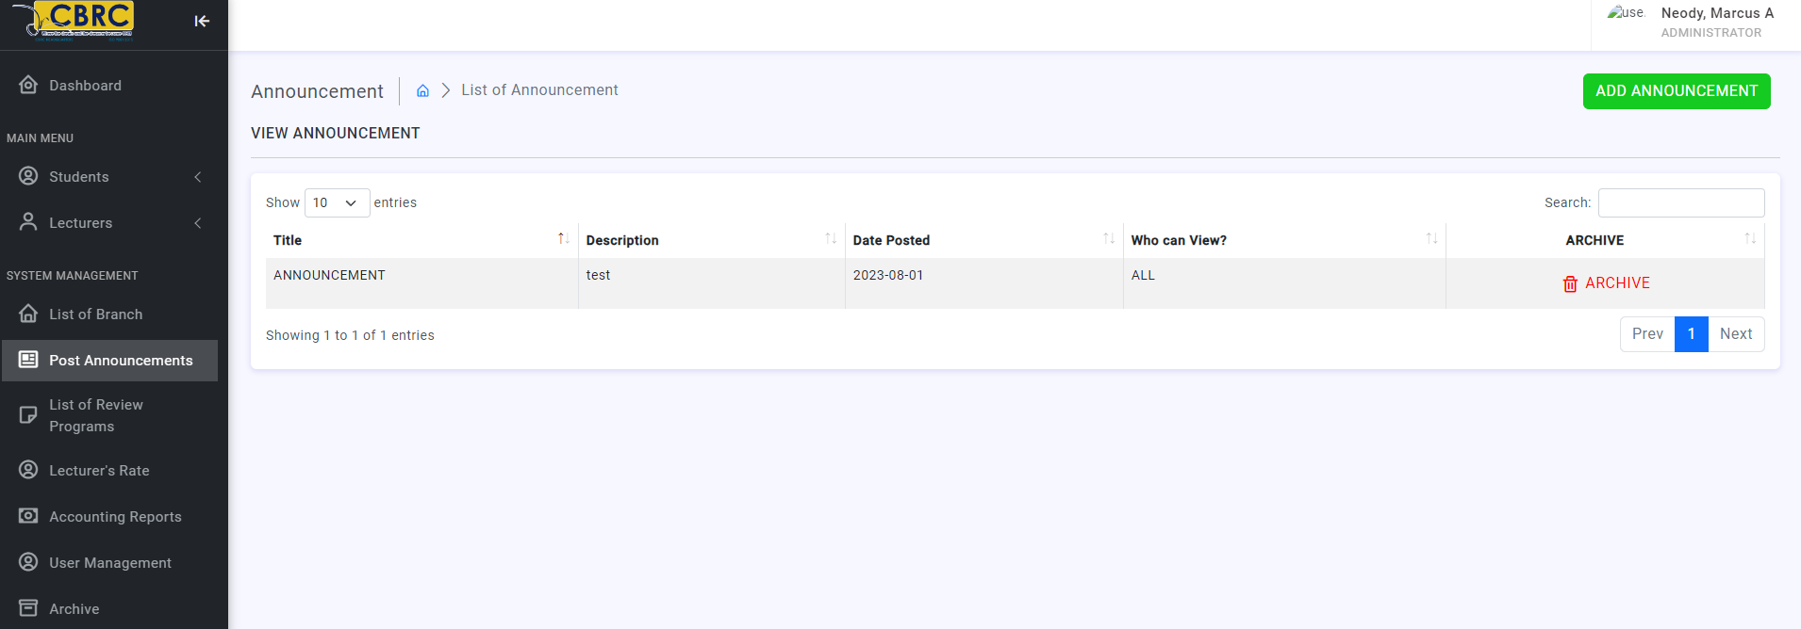

After click ng “Archive” button nag direct lang sa Archive tab pero wala dun yung Announcement

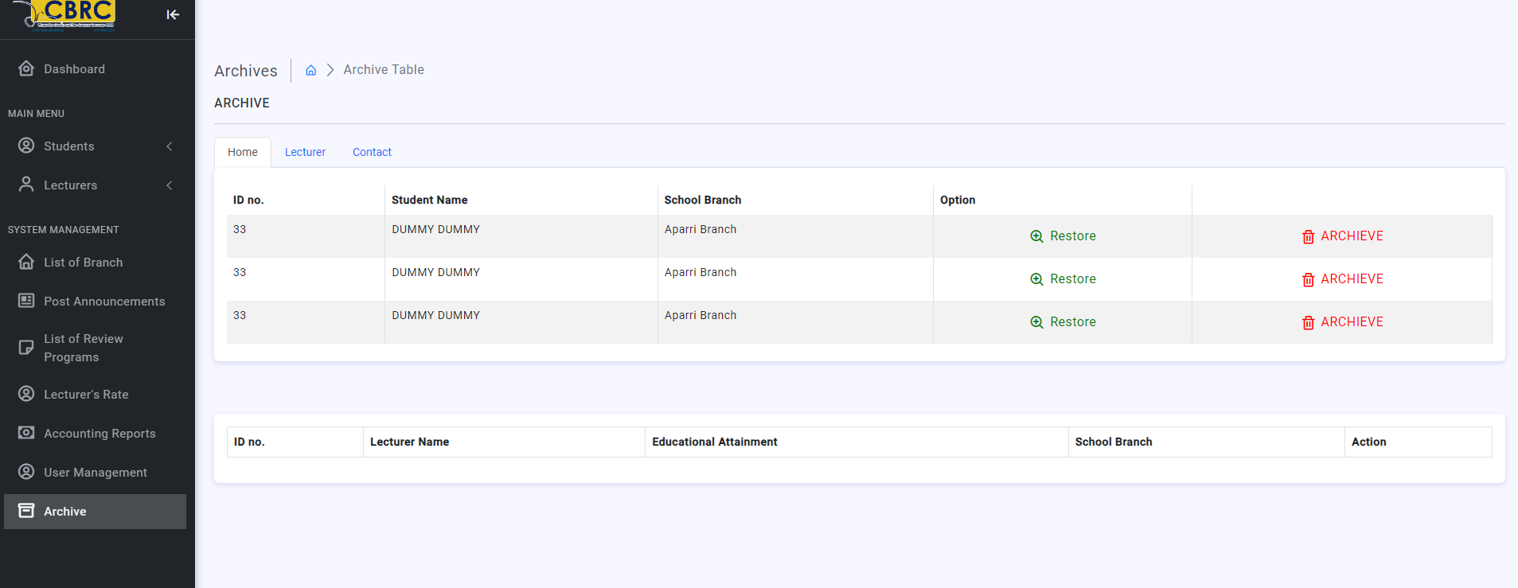

1. <http://localhost/enrollment/admin/dashboard.php> (**Aug2 ganun pa din)**

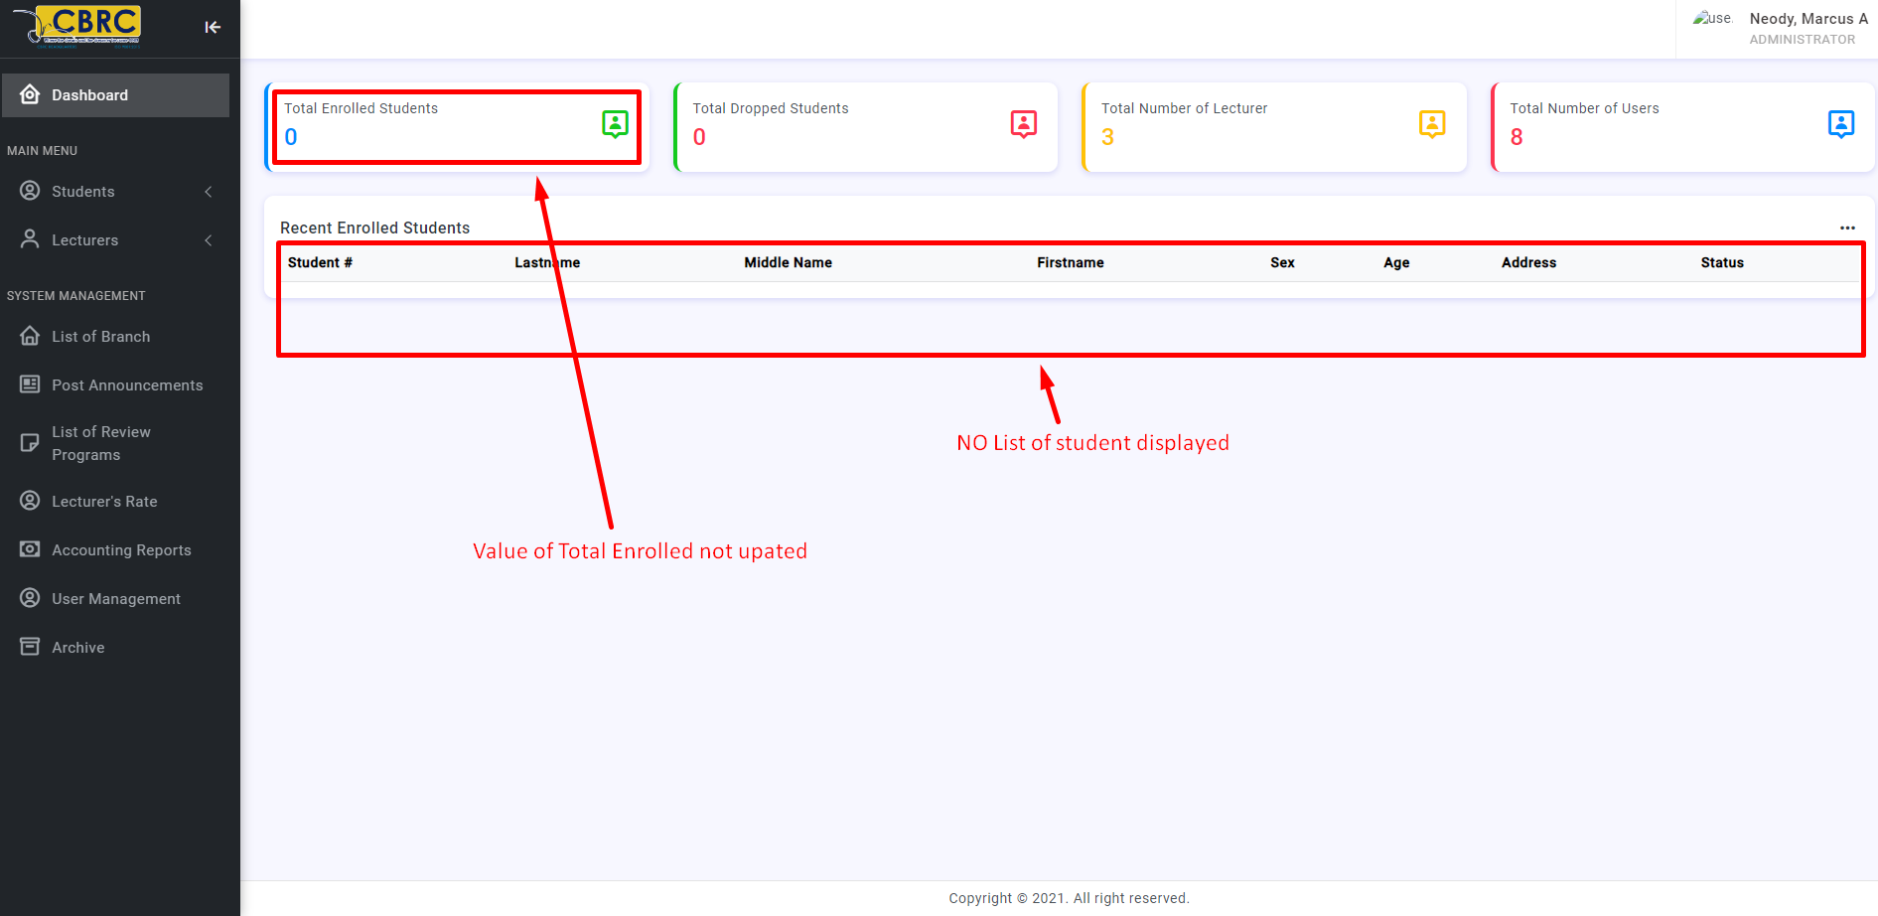

1. <http://localhost/enrollment/admin/student_list.php>

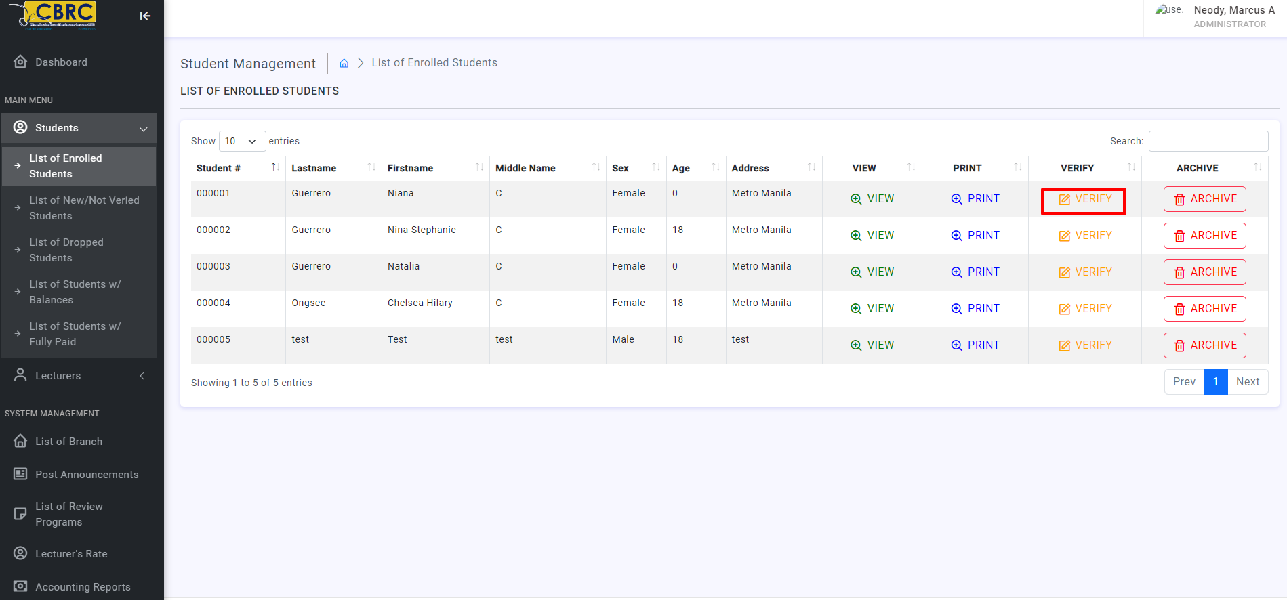

Pag click ng “verify” button” this is the error

**Warning**: Undefined array key "id" in **C:\xampp\htdocs\enrollment\admin\edit_student.php** on line **3**

**Fatal error**: Uncaught mysqli_sql_exception: Unknown column 'student_numer' in 'where clause' in C:\xampp\htdocs\enrollment\admin\edit_student.php:5 Stack trace: #0 C:\xampp\htdocs\enrollment\admin\edit_student.php(5): mysqli_query(Object(mysqli), 'UPDATE es_stude...') #1 {main} thrown in **C:\xampp\htdocs\enrollment\admin\edit_student.php** on line **5**

After clicking the “verify” button napupunta sa “List of New/Not Veried Students” which is correct and we expecting to happened

<http://localhost/enrollment/admin/unverified_student_list.php>

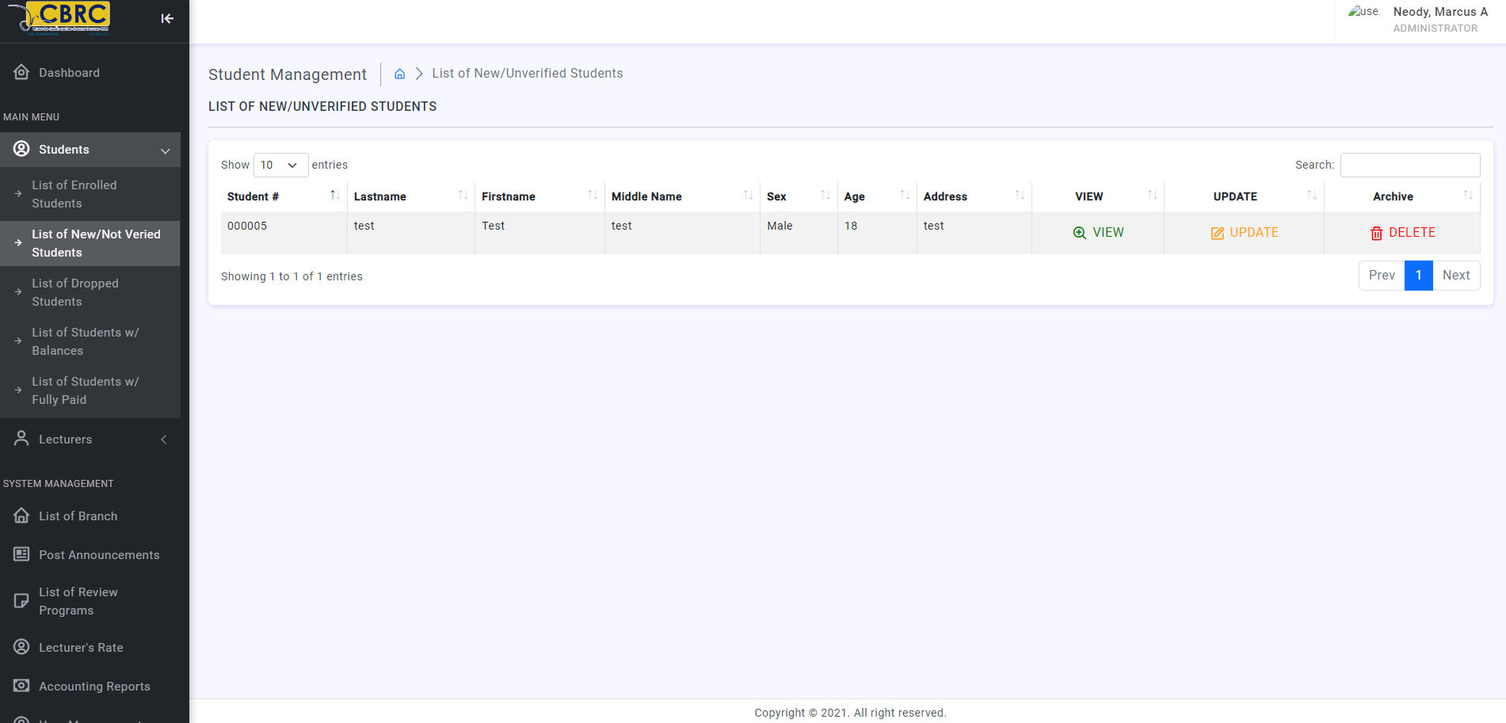

1. But pag click ng “view” button <http://localhost/enrollment/admin/edit_transaction.php?id=000005>

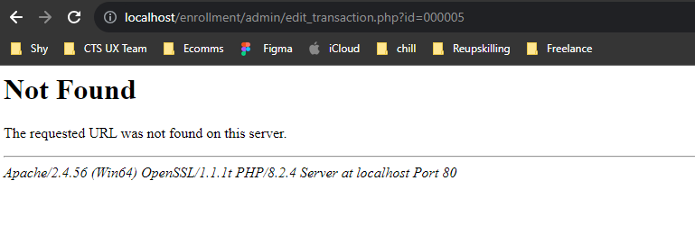

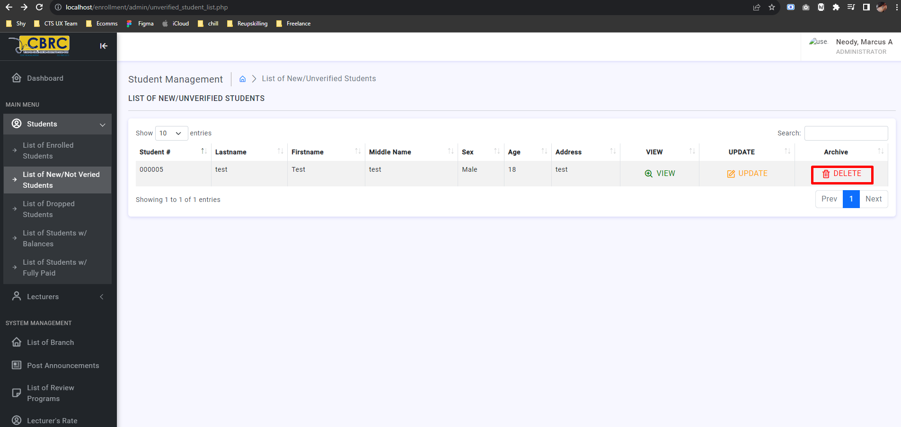

Change Delete to “Achive” button **(DONE by Shy)**

1. Delete “Update” button on this following list page: **(DONE by Shy)**
   1. <http://localhost/enrollment/admin/unverified_student_list.php>
   2. <http://localhost/enrollment/admin/lecturers_list.php>
   3. <http://localhost/enrollment/admin/lecturers_sched.php>
   4. <http://localhost/enrollment/admin/branch.php>
   5. <http://localhost/enrollment/admin/announcement.php>
   6. <http://localhost/enrollment/admin/review_programs.php>
   7. <http://localhost/enrollment/admin/unverified_student_list.php>
   8. <http://localhost/enrollment/admin/lecturers_salary.php?lec_id=1%20&%20lec_name=Luna,%20Juan%20C>